# **1. Project Overview**

In this project our goal is to develop five classification-based machine learning model. These models are Support Vector Machine (SVM), Decision Tree (DT), K-Nearest Neighbor (KNN), Logistic regression (LR) and Naive Bayes (NB). In classification-based machine learning after loading the dataset and our first job is to preprocess the data i.e., is cleaning the data set if there are any empty cells, wrong data, data in wrong format or duplicate data. For empty cells depending on size of the dataset we either refill the value or remove the rows or columns. We usually use Mean, Median, Mode value to refill the empty cells. Depending on the size of dataset if the number of missing values is more than 70% it’s wise to remove the rows or columns since the data provided is insufficient to train and test the model. If there is wrong data, Wrong data means the data value is wrong. For example, "Duration" column should have values 30 to 60, but someone written 450, which is wrong. Sometimes you can spot wrong data by looking at the data set, because you have an expectation of what it should be. We can fix these value iterating through the columns. In case of data in wrong format, we can either remove the columns, or convert all cells in the columns into the same format. Since, ﻿cells with data of wrong format can make it difficult, or even impossible, to analyze data. For duplicate data we simply remove them from the dataset so they cannot manipulate the model. Exploratory Data Analysis is a very important step before training the model. ﻿We will use some visualizations to understand the relationship of the target variable with other feature variables. Next, we create a correlation matrix that measures the linear relationships between the variables. Features that correlate together may make interpretability of their effectiveness difficult). We can also use parallel plot; a parallel plot allows to compare the feature of several individual observations (series) on a set of numeric variables. Interestingly, Pandas is probably the best way to plot a parallel coordinate plot with python. When we develop model, we create feature matrix, with relevant columns to find the optimize output. We also need to set the target which will be our goal to predict. Then we split the dataset for training and testing the model. Depending on the size of model it’s a standard practice to split the training and testing dataset to 80-20 or 70-30. Finally, we fit the machine learning model with testing dataset. To train the model means we need to give both features and target so that machine can develop a mathematical formula or an algorithm which find relation between the features and target. For predicting, we need to provide the testing dataset that only contain the feature which will predict the target. And to measure the accuracy of the model we compare the predicted results with the testing target. The higher the accuracy the better it is.

# **2. Dataset Overview**

**Source:** <https://www.kaggle.com/datasets/teejmahal20/airline-passenger-satisfaction>



**Scan QR code to visit source**

**Description:**

This dataset contains an airline passenger satisfaction survey. What factors are highly correlated to a satisfied (or dissatisfied) passenger. It has 25 different columns and 103904 instances.

**Gender:** Gender of the passengers (Female, Male)

**Customer Type:** The customer type (Loyal customer, disloyal customer)

**Age:**The actual age of the passengers

**Type of Travel:** Purpose of the flight of the passengers (Personal Travel, Business Travel)

**Class:** Travel class in the plane of the passengers (Business, Eco, Eco Plus)

**Flight distance**: The flight distance of this journey

**Inflight wifi service:**Satisfaction level of the inflight wifi service (0:Not Applicable;1-5)

**Departure/Arrival time convenient:** Satisfaction level of Departure/Arrival time convenient

**Ease of Online booking:** Satisfaction level of online booking

**Gate location:** Satisfaction level of Gate location

**Food and drink:** Satisfaction level of Food and drink

**Online boarding:** Satisfaction level of online boarding

**Seat comfort:** Satisfaction level of Seat comfort

**Inflight entertainment:** Satisfaction level of inflight entertainment

**On-board service:** Satisfaction level of On-board service

**Leg room service:** Satisfaction level of Leg room service

**Baggage handling:** Satisfaction level of baggage handling

**Check-in service:** Satisfaction level of Check-in service

**Inflight service:** Satisfaction level of inflight service

**Cleanliness:** Satisfaction level of Cleanliness

**Departure Delay in Minutes:** Minutes delayed when departure

**Arrival Delay in Minutes:** Minutes delayed when Arrival

**Satisfaction:** Airline satisfaction level(Satisfaction, neutral or dissatisfaction)

# **3. Data Preprocessing and Exploratory data analysis**

# 

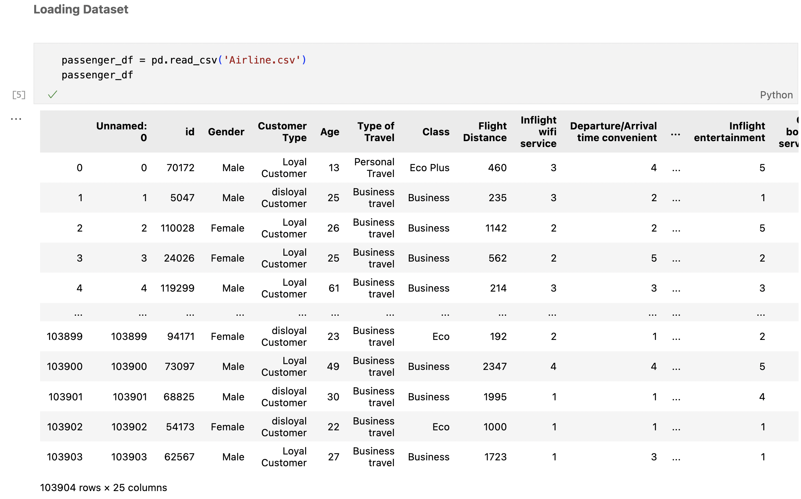

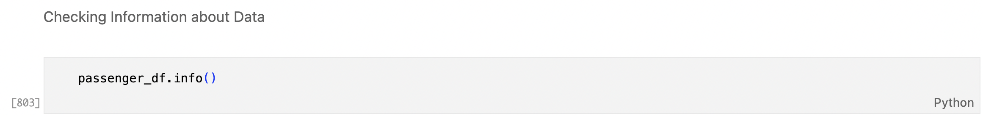

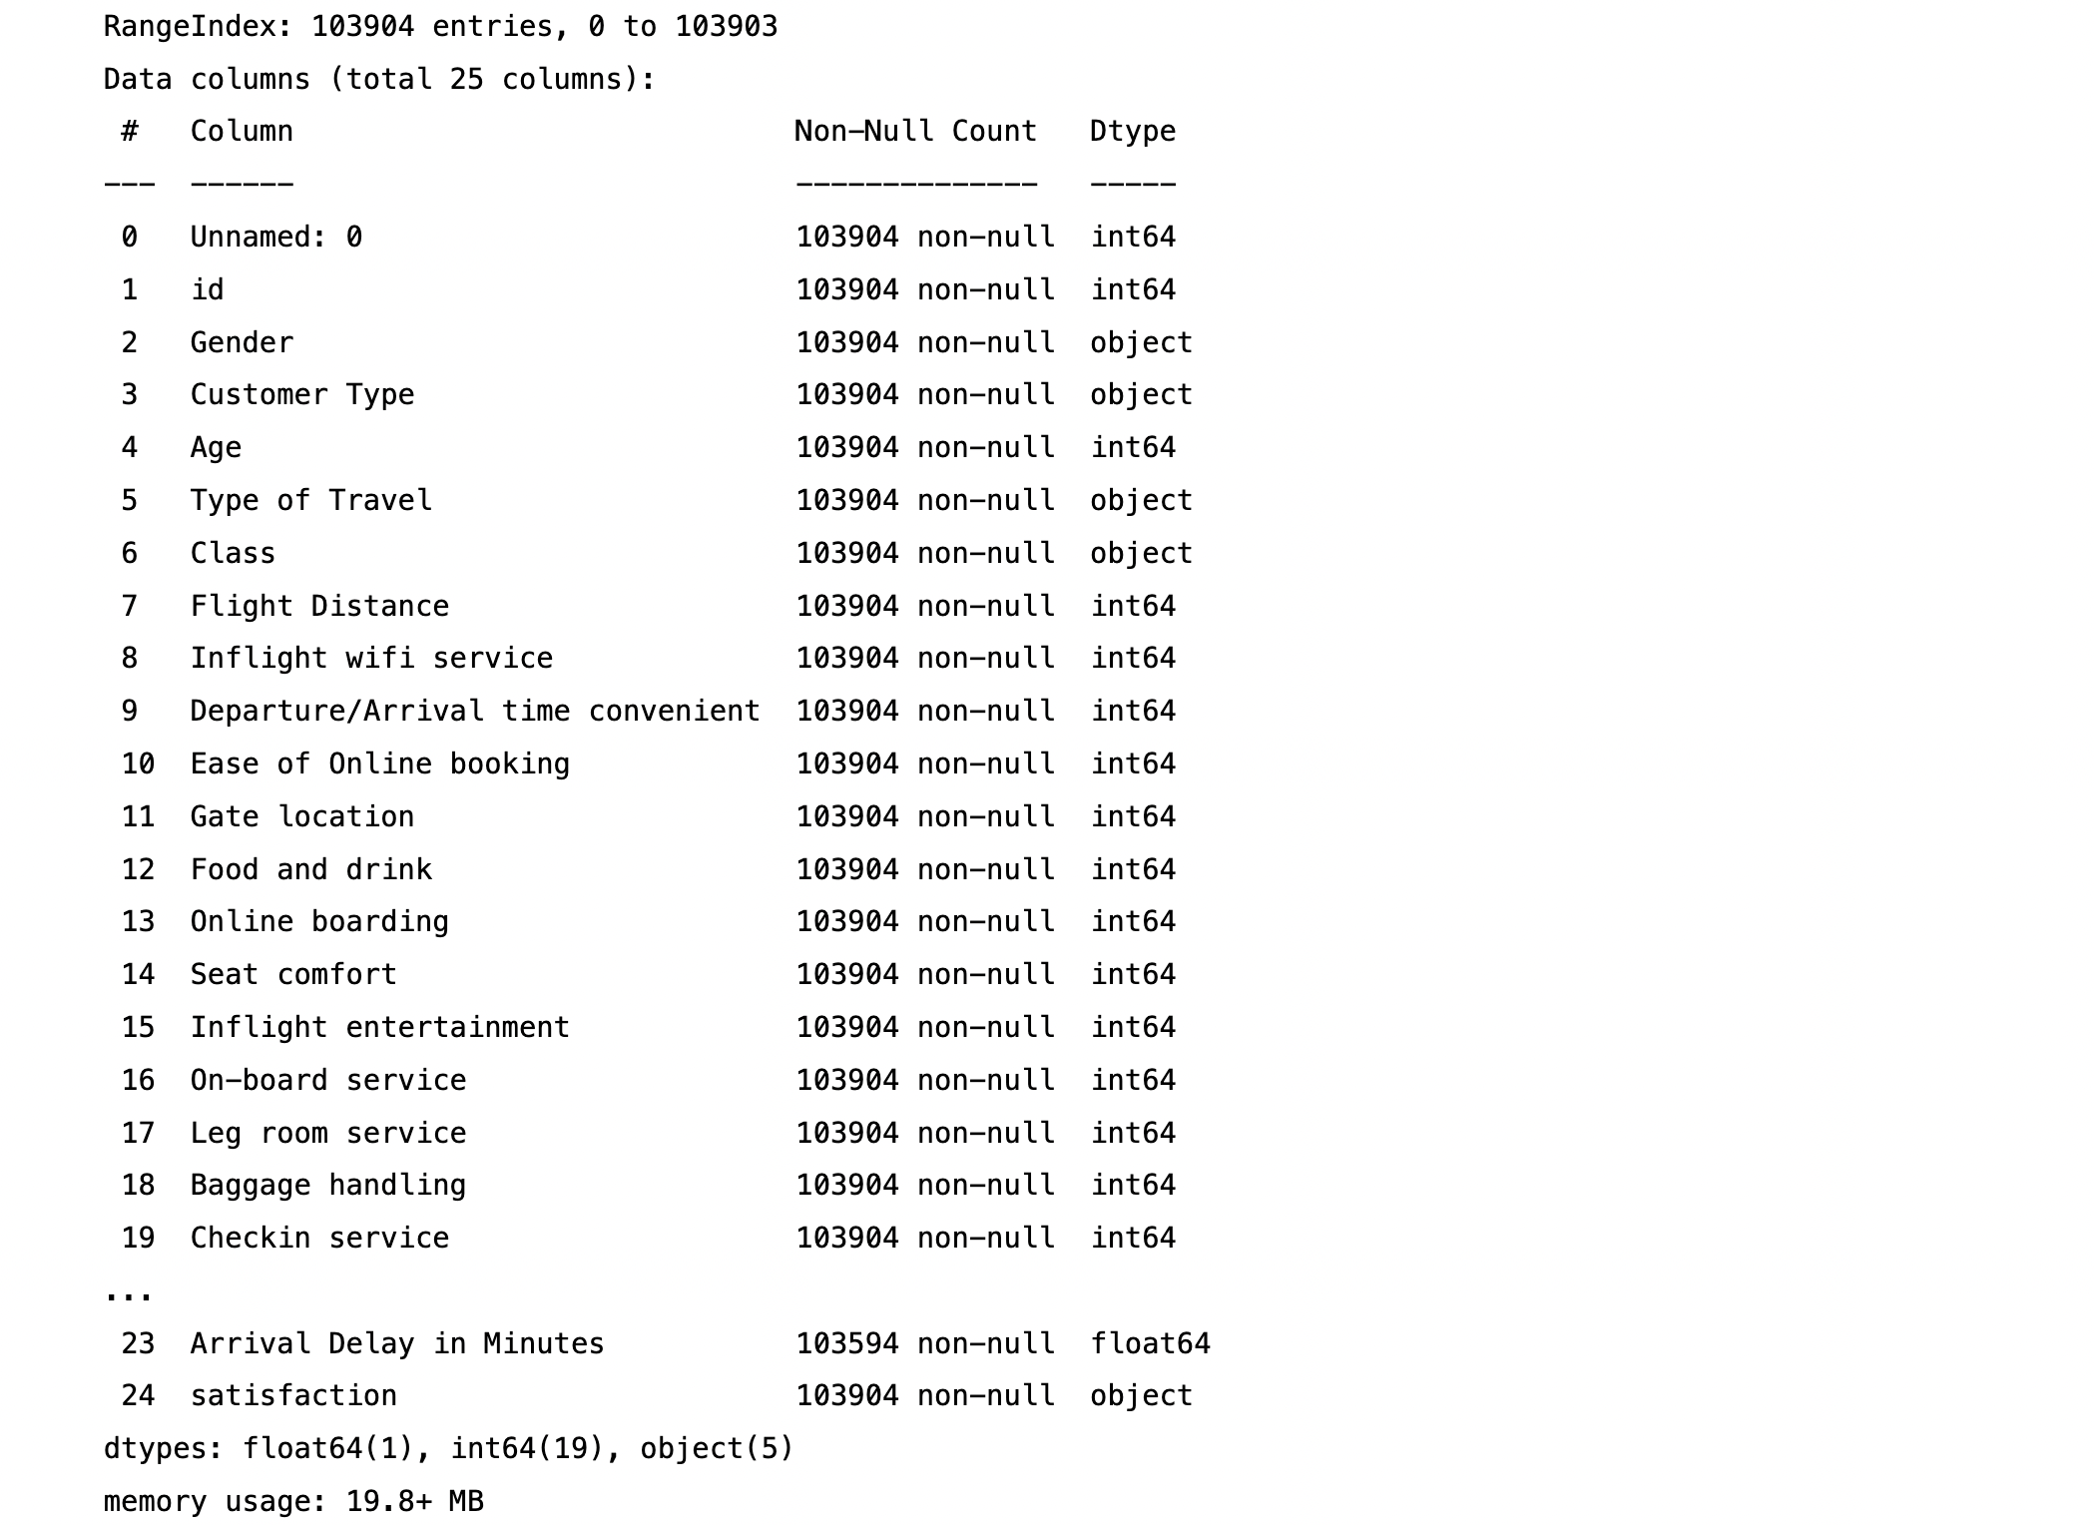

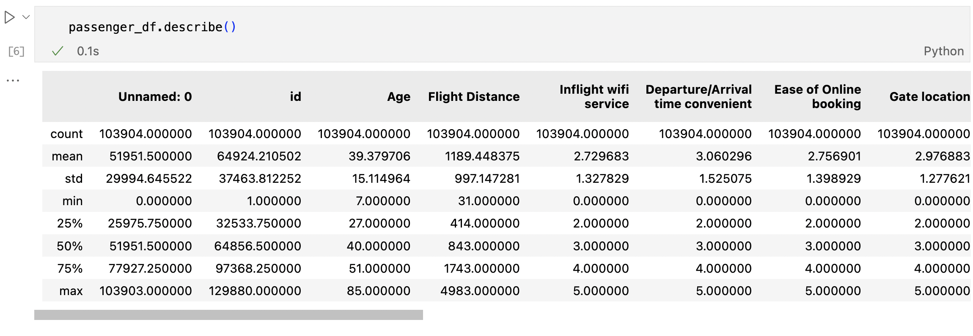

# **Data Preprocessing:**

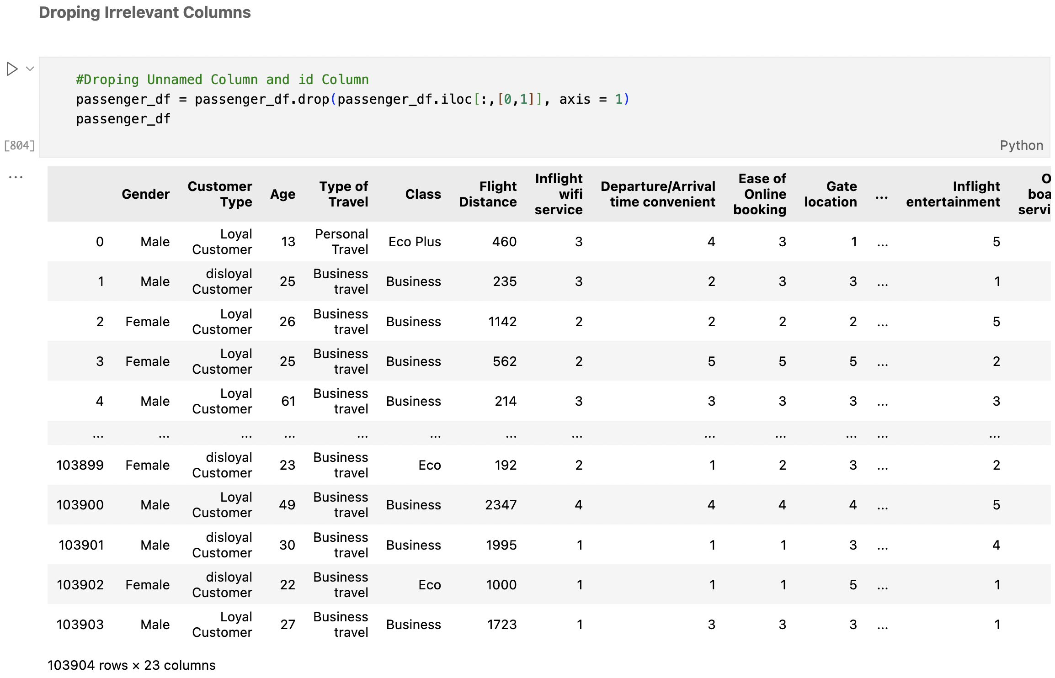

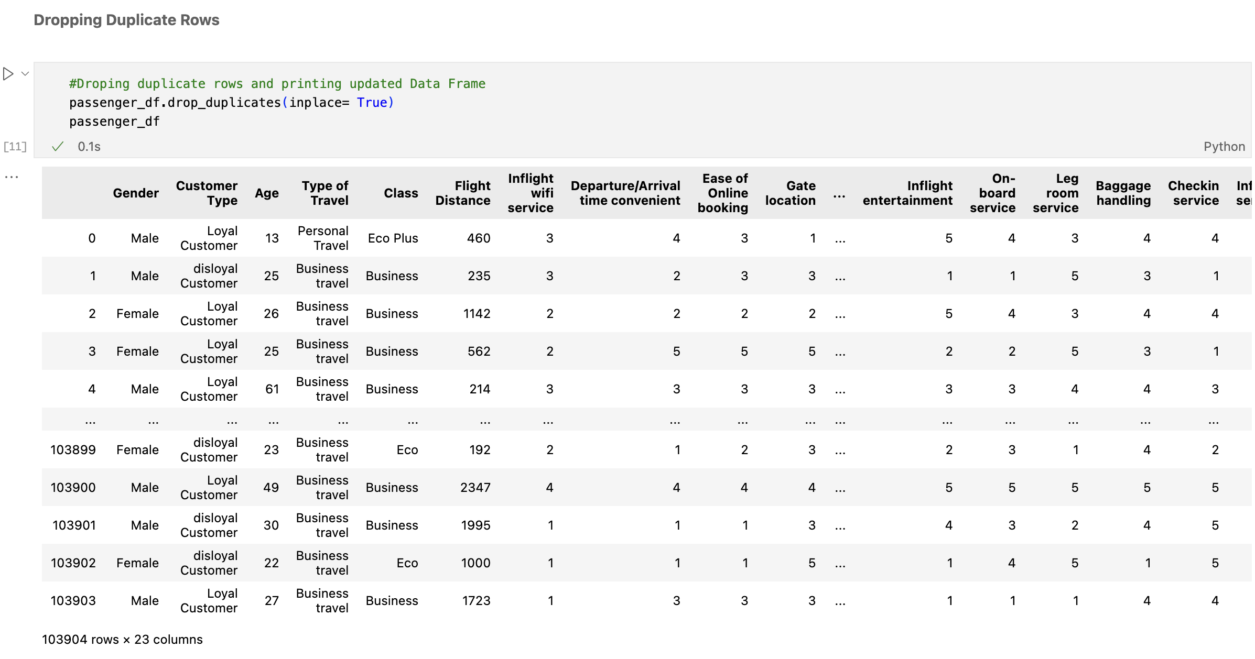

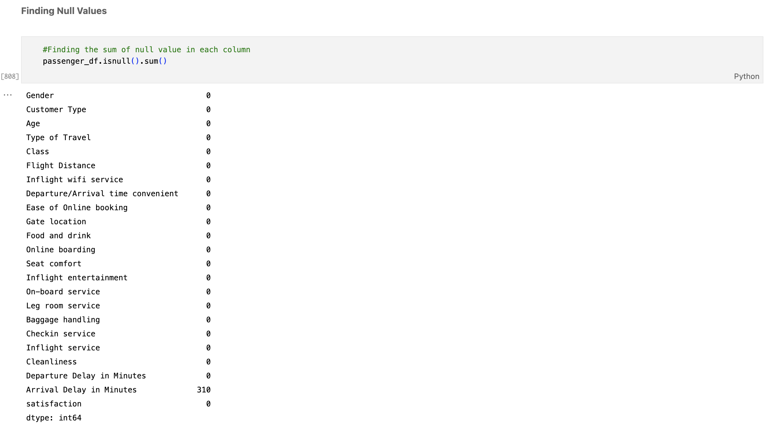

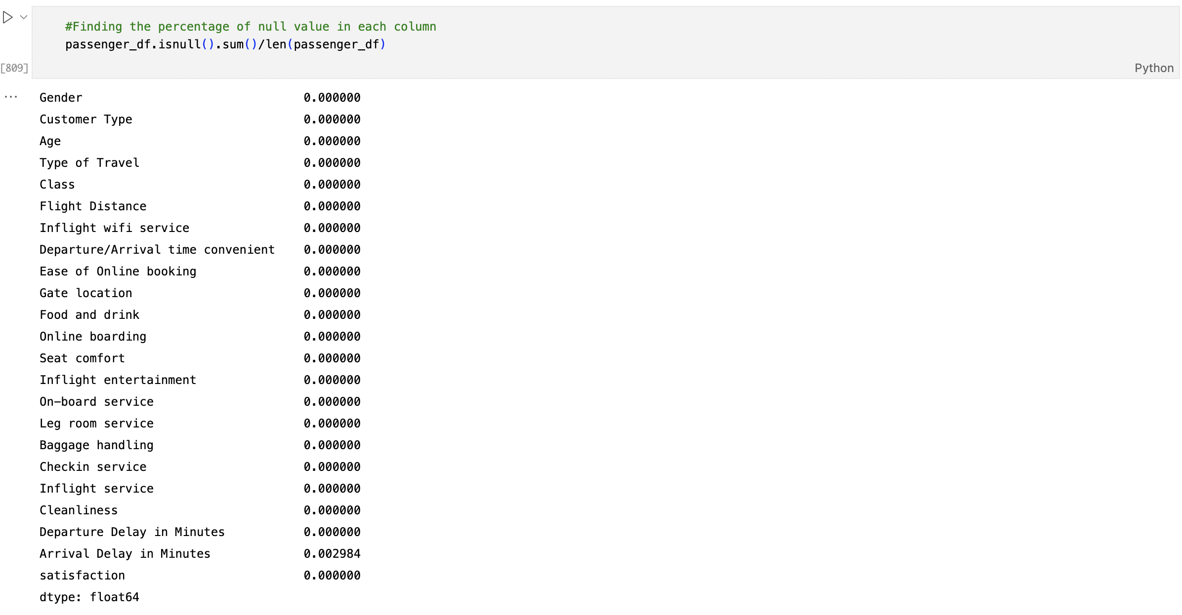

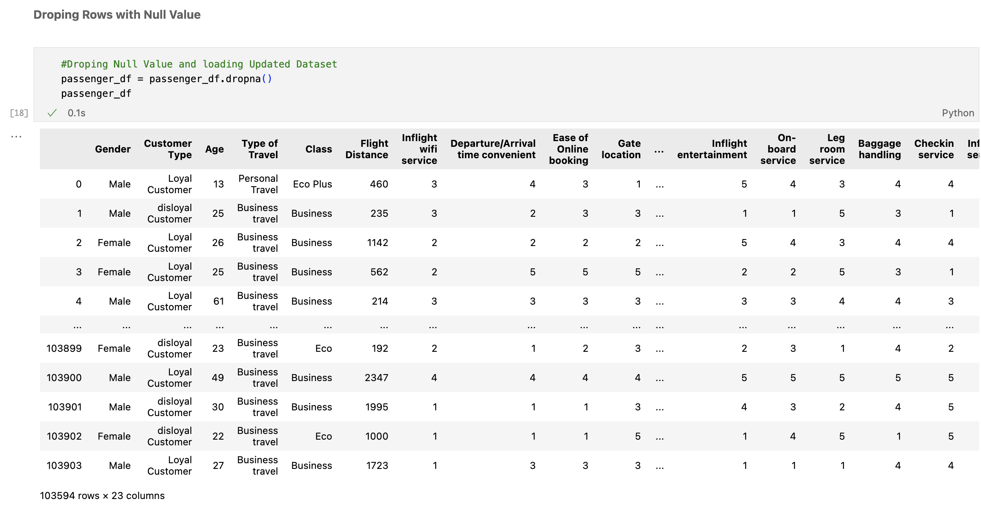

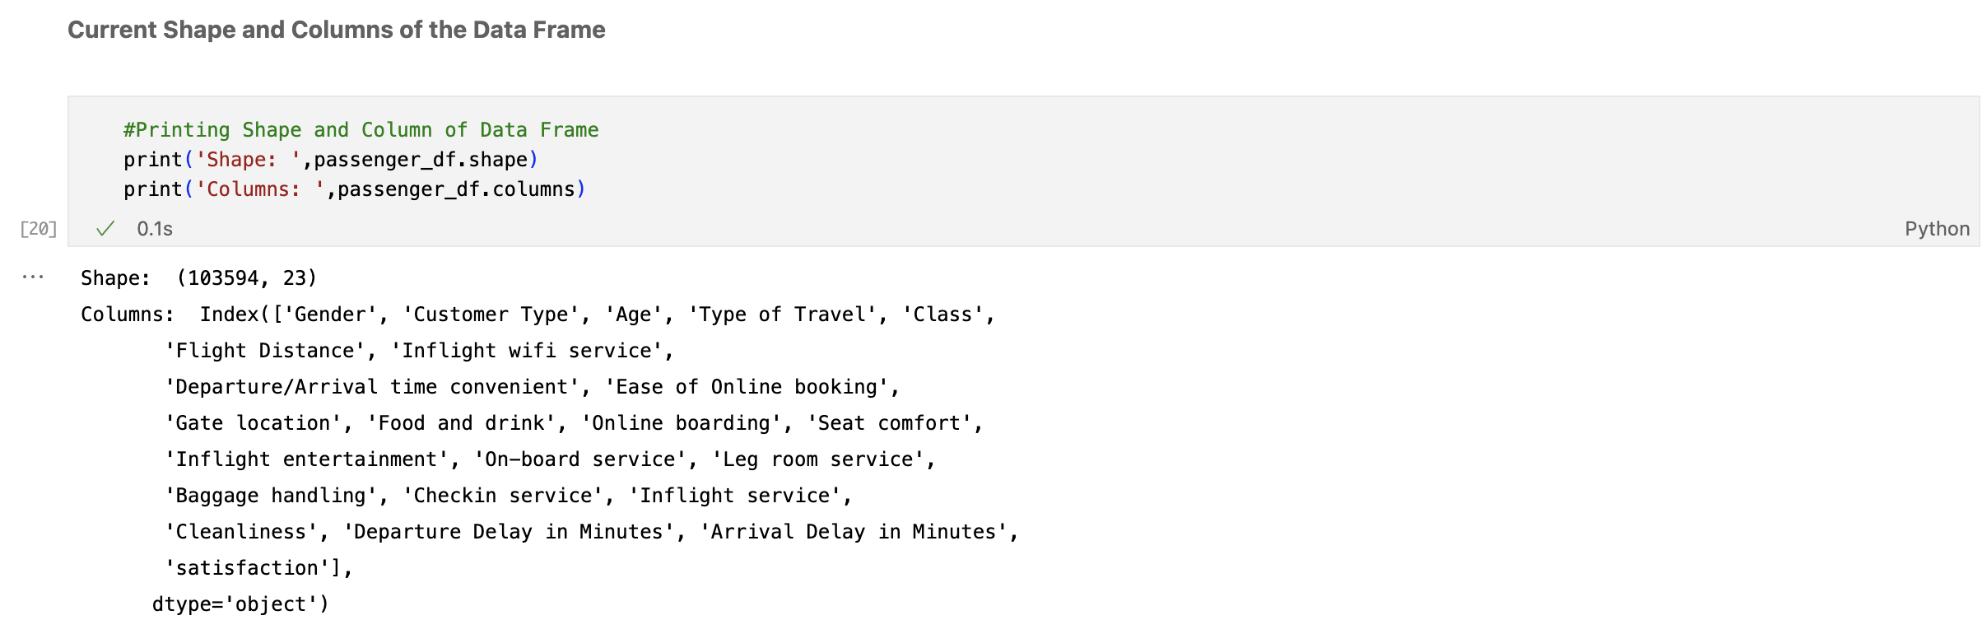

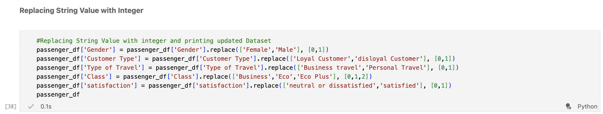

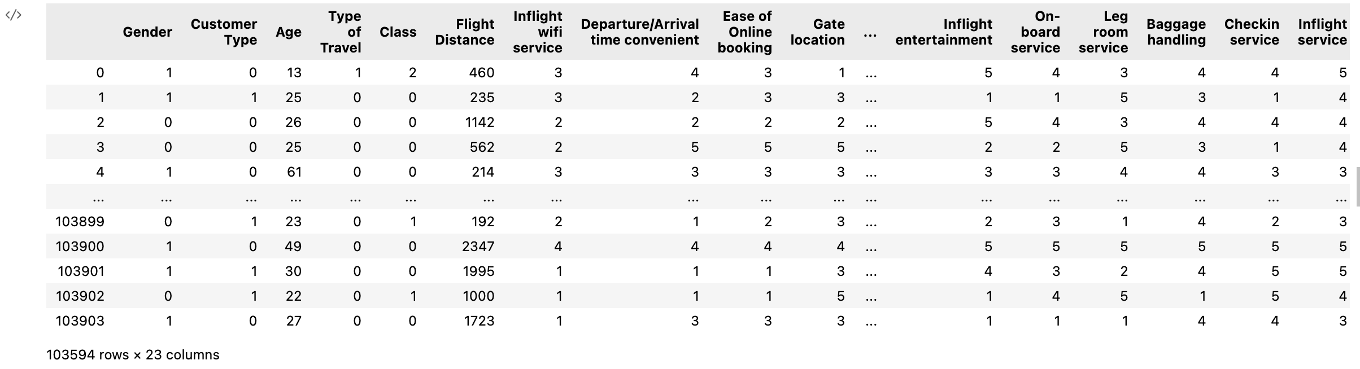

# **Exploratory Data Analysis:**

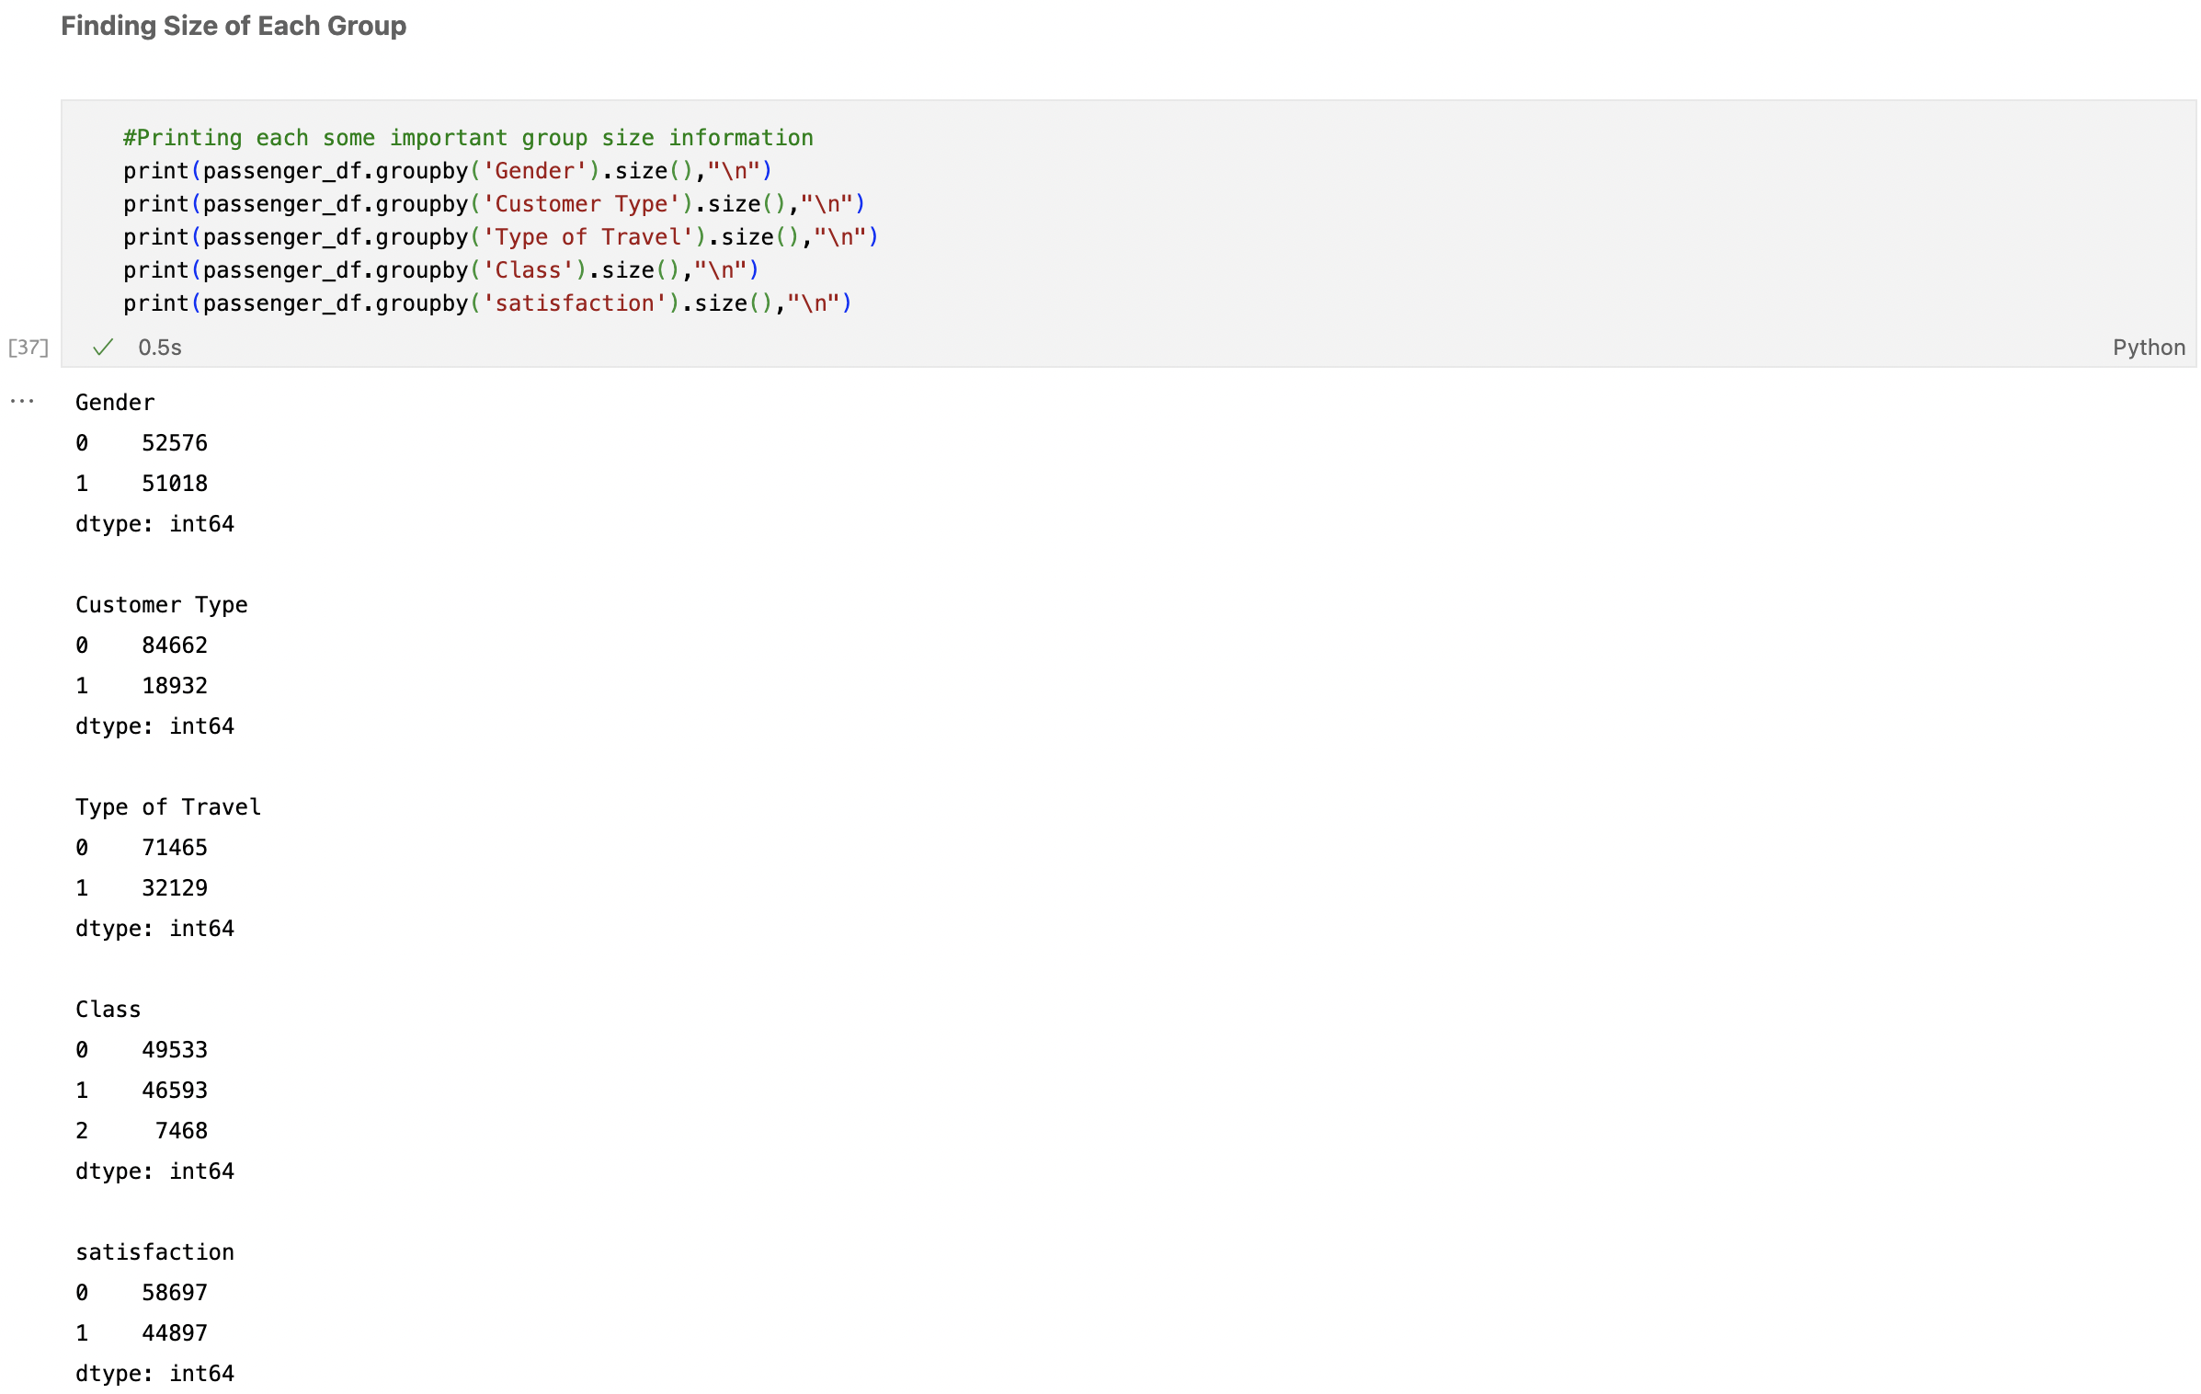

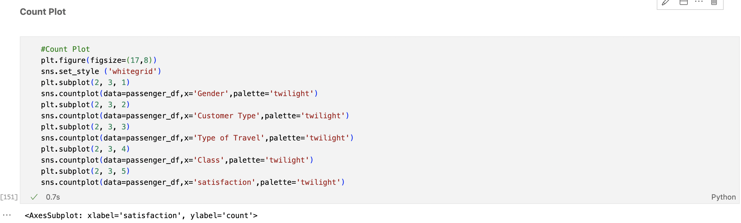

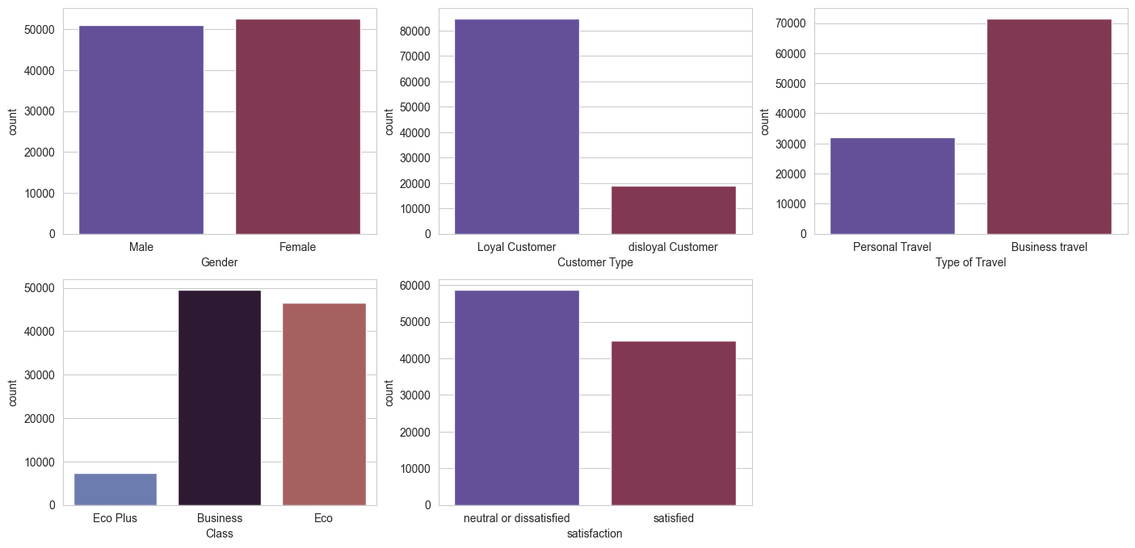

Figure: Count Plot

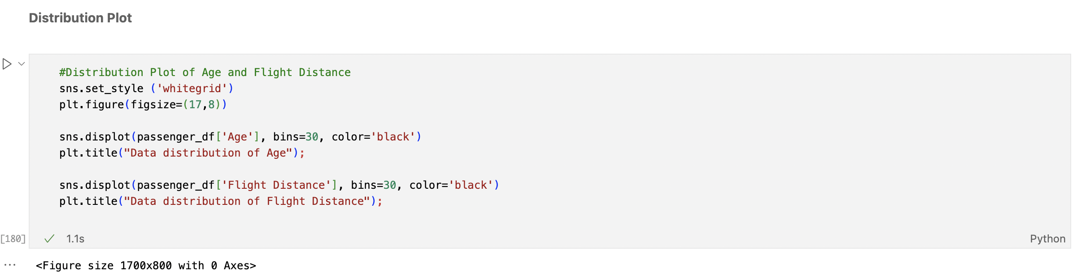

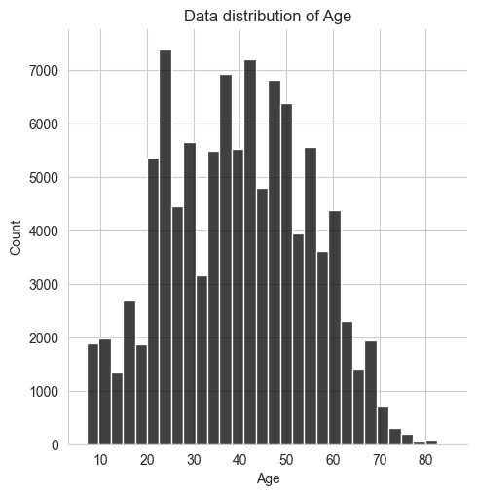 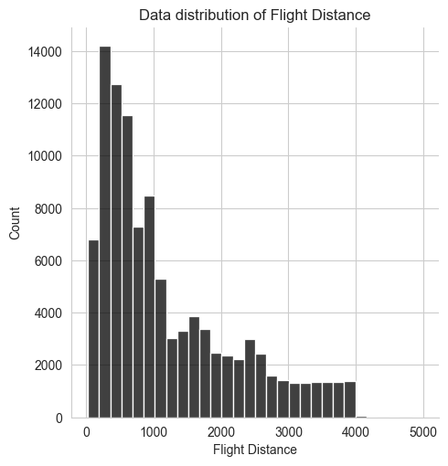

Figure: Distribution Plot

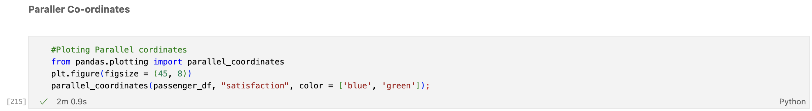

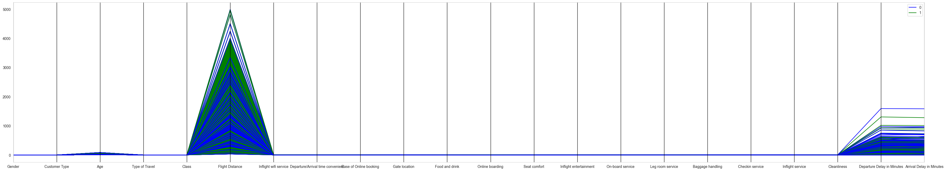

Figure: Parallel Co-ordinates

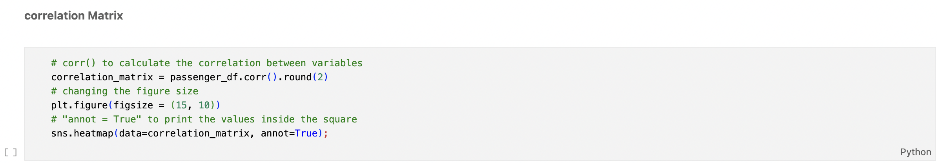

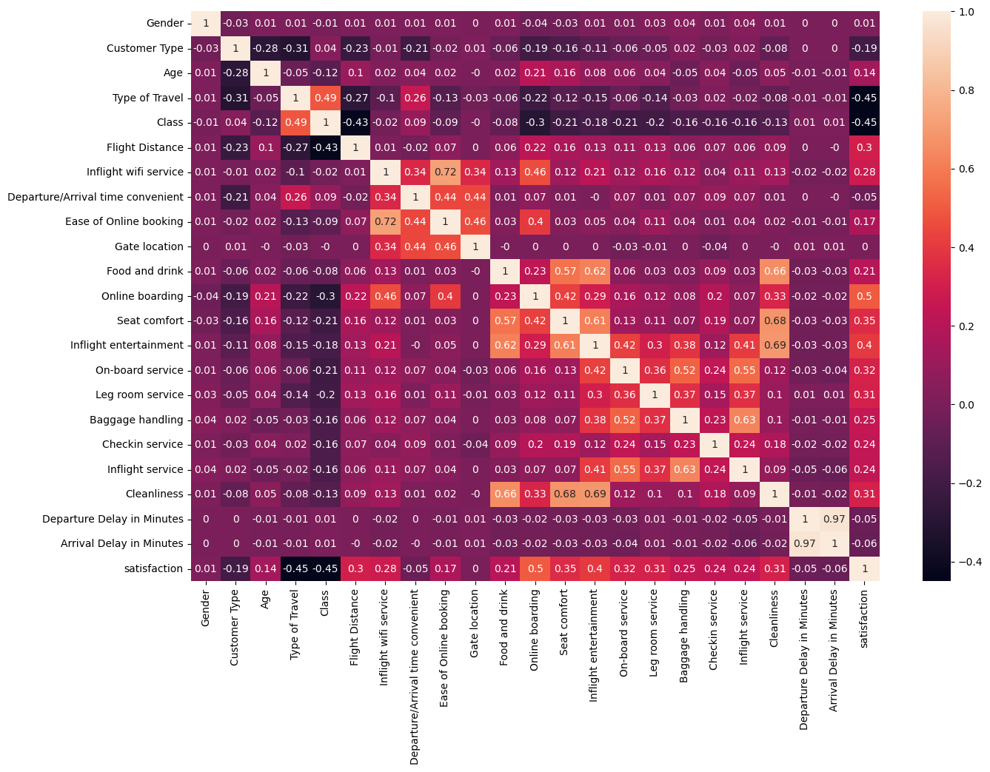

Figure: Correlation Matrix

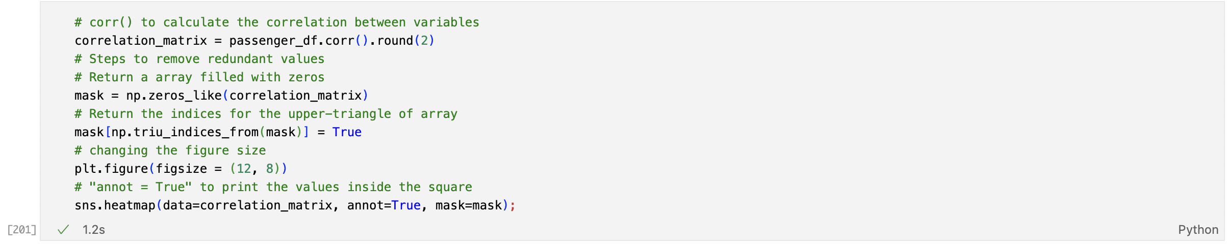

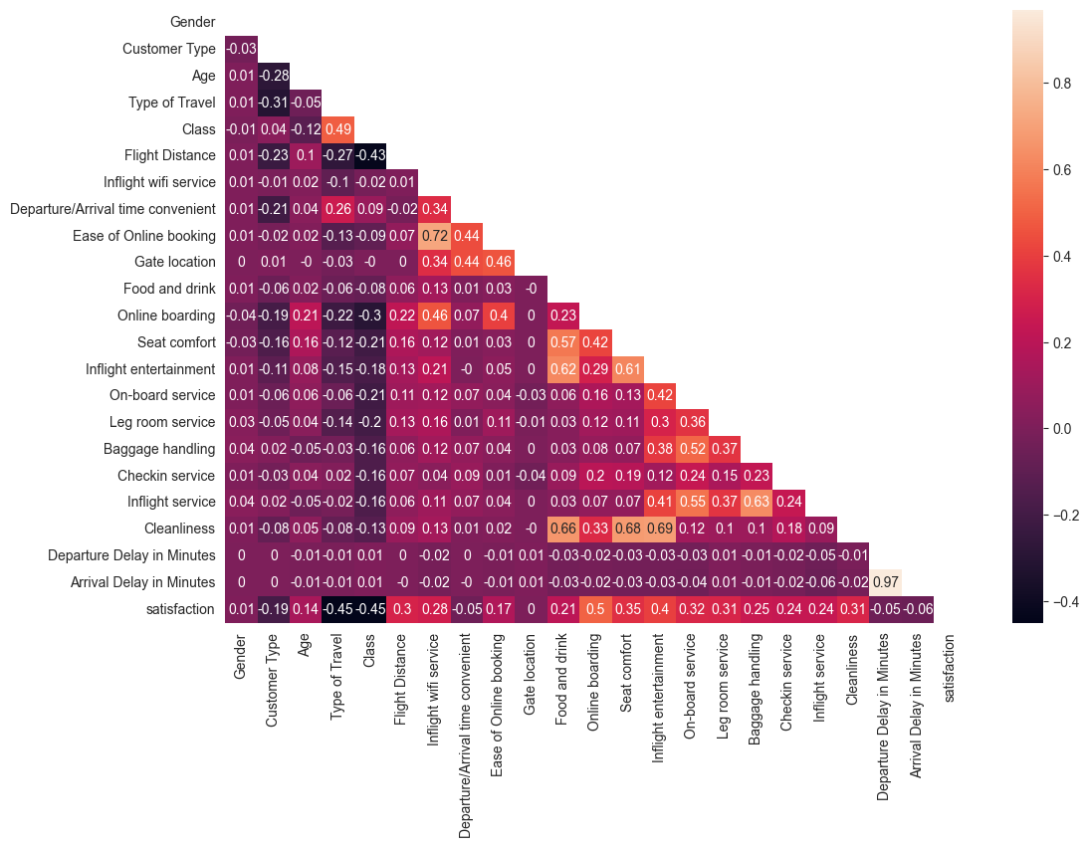

Figure: Correlation Matrix

# **4. Model Development**

For model development we have remove features which has either high correlation or no correlation with the help of correlation matrix. We only considered relevant variable such as Type of Travel, Inflight wifi service, Online boarding, Seat comfort, Inflight entertainment, On-board service, Leg room service, Baggage handling, Checkin service, Inflight service, Cleanliness' for feature matrix. And our Target variable is satisfaction.

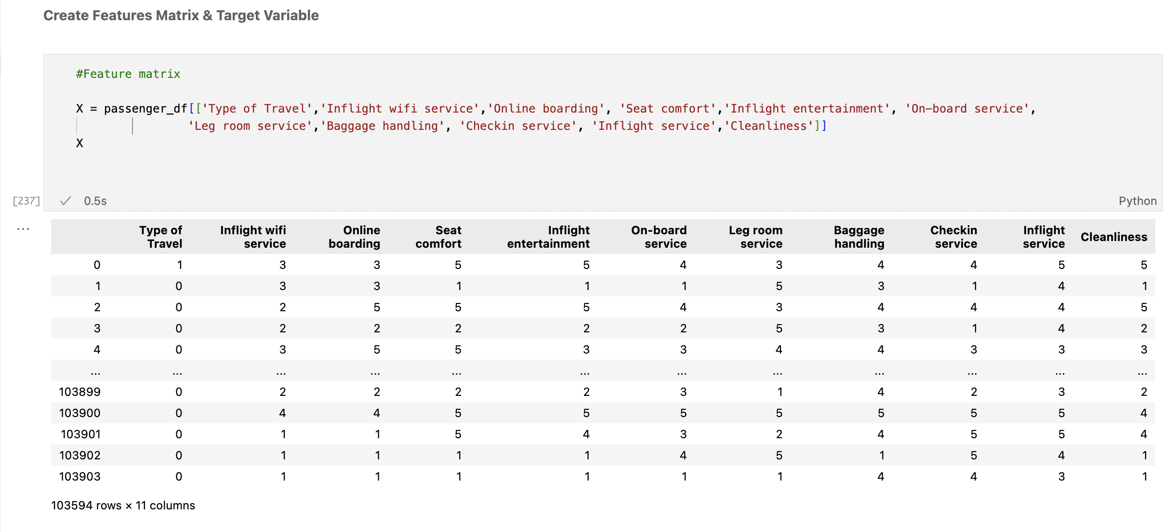

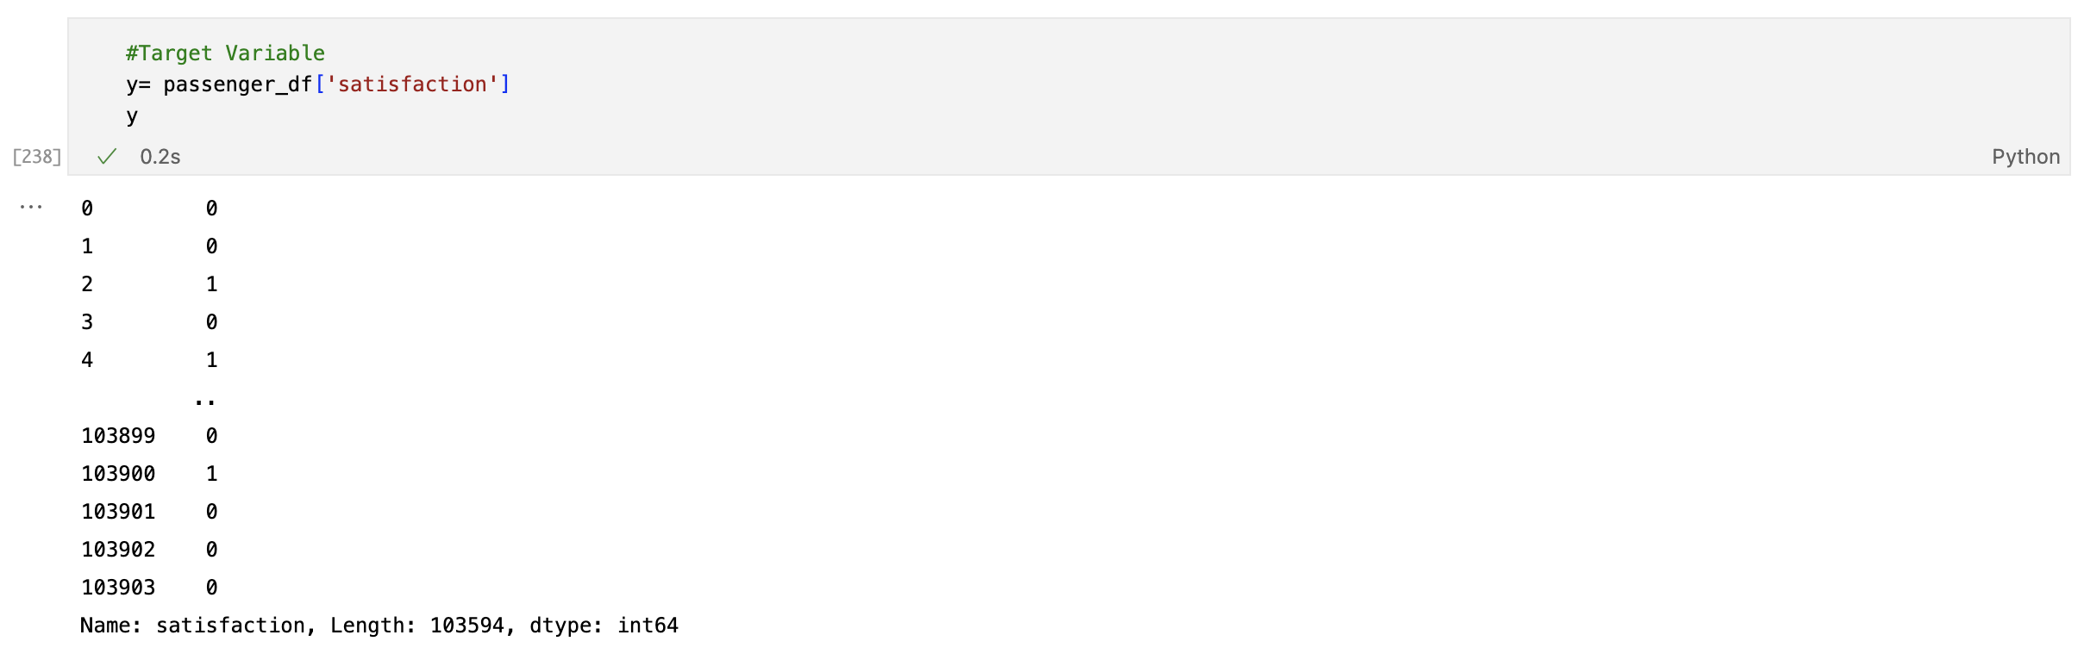

To split the dataset for training and testing the model we used train test split module from scikit learn, we split the dataset into 70-30 ratio for training and testing. Among 103594 rows 72515 rows were randomly selected for training and 31079 were selected for testing the model’s prediction accuracy.

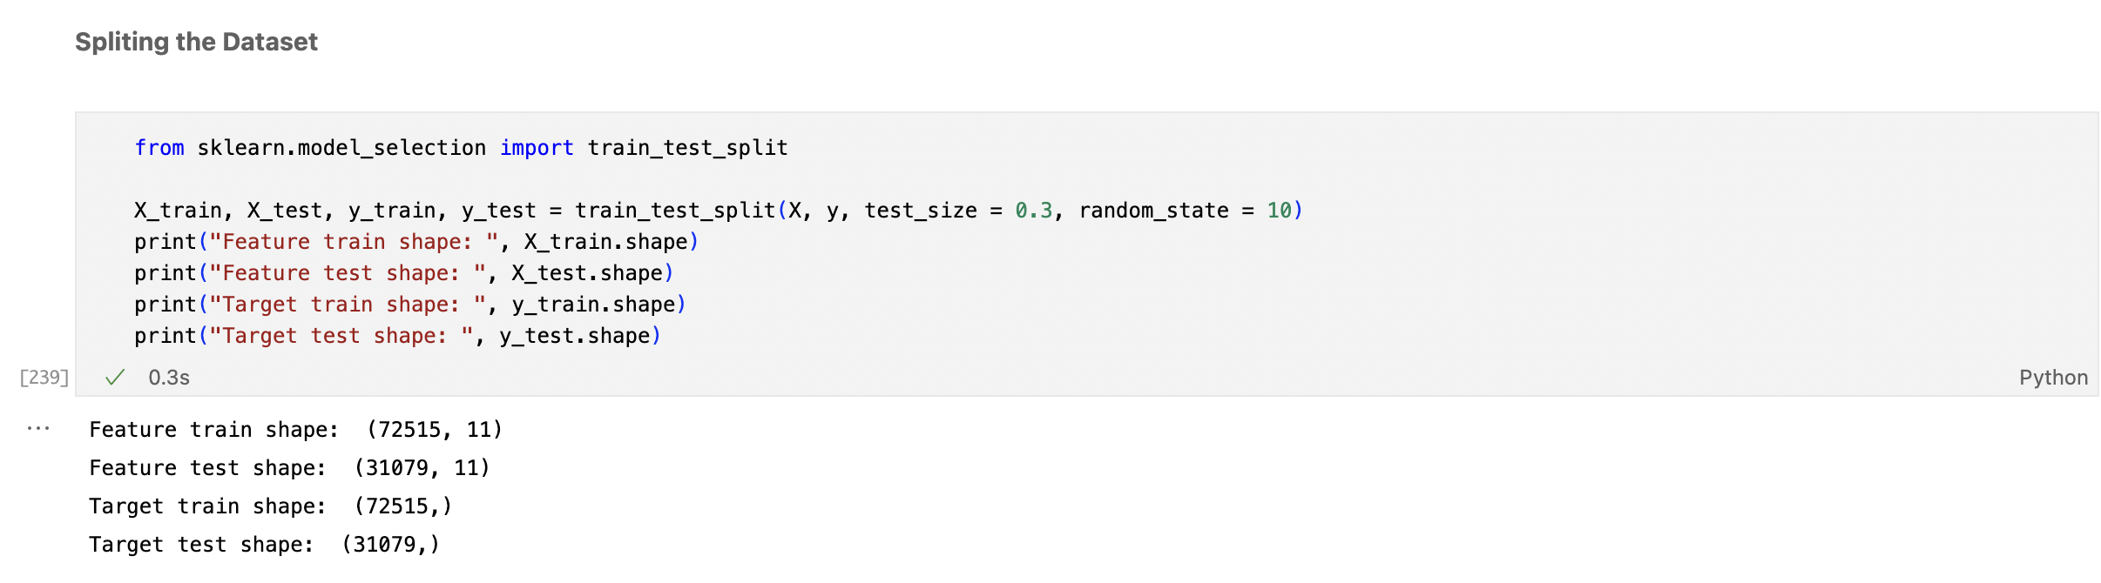

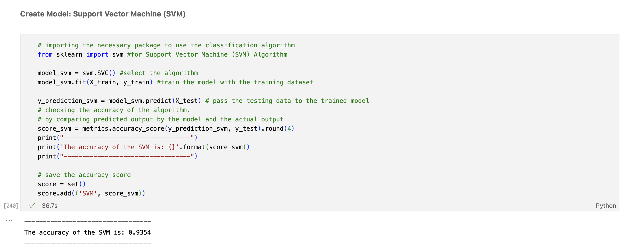

For Support Vector Machine (SVM) we imported the model from scikit learn and we fitted the model with both features and target for training and once the model is ready it’s tested with only the testing features and the predicted outcome is then compared with the actual outcome to find the accuracy. For Support Vector Machine (SVM) the accuracy is almost 93.5% which is excellent.

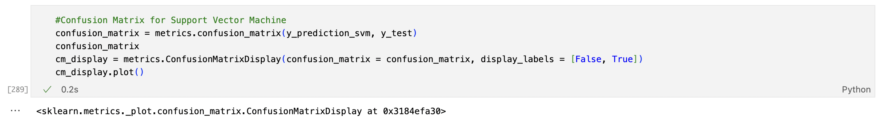

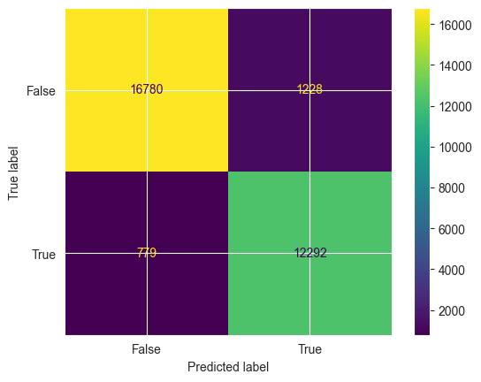

Figure: Confusion Matrix for Support Vector Machine (SVM)

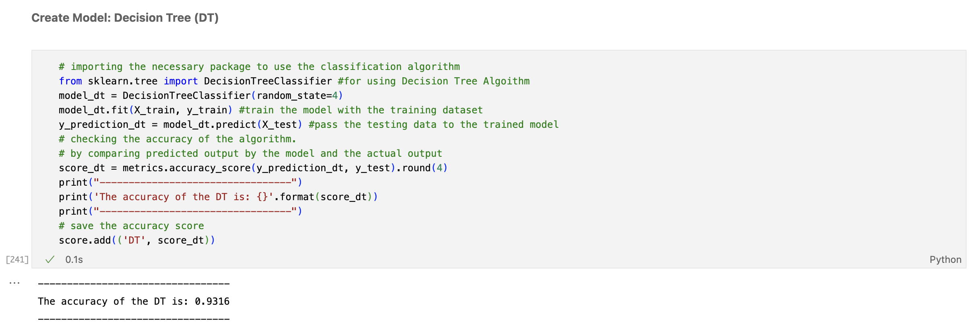

For Decision Tree (DT) we imported the model from scikit learn and we fitted the model with both features and target for training and once the model is ready it’s tested with only the testing features and the predicted outcome is then compared with the actual outcome to find the accuracy. For Decision Tree (DT) the accuracy is almost 93 % which is also excellent.

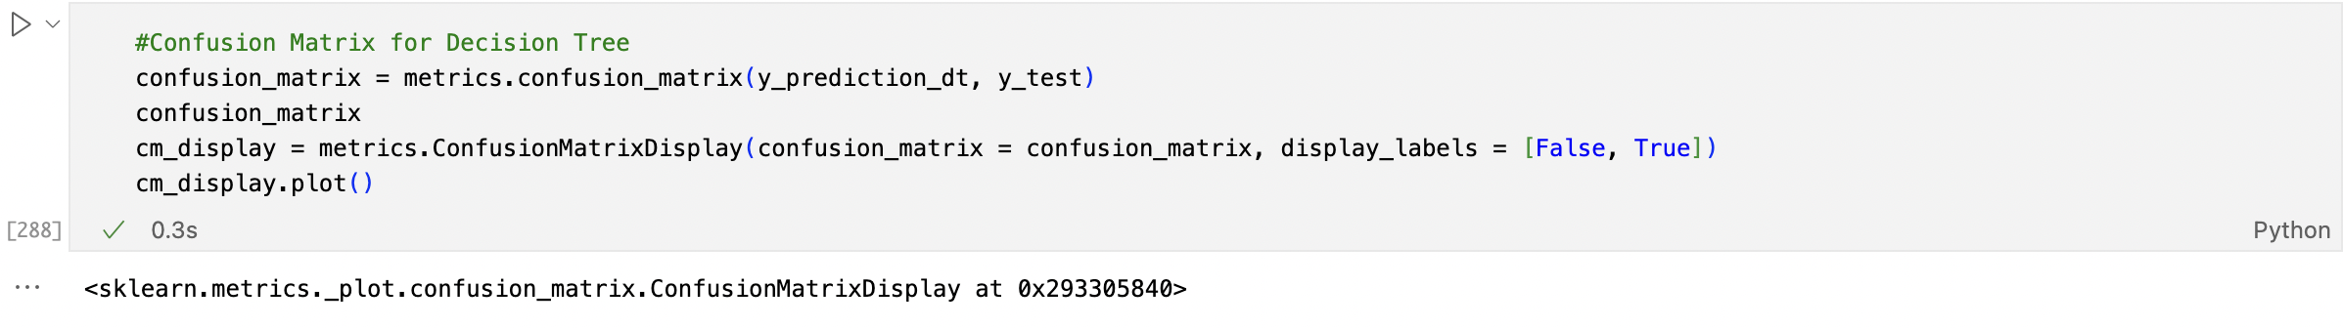

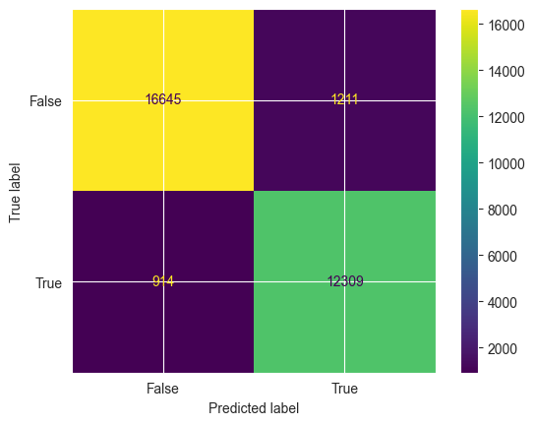

Figure: Confusion Matrix for Decision Tree (DT)

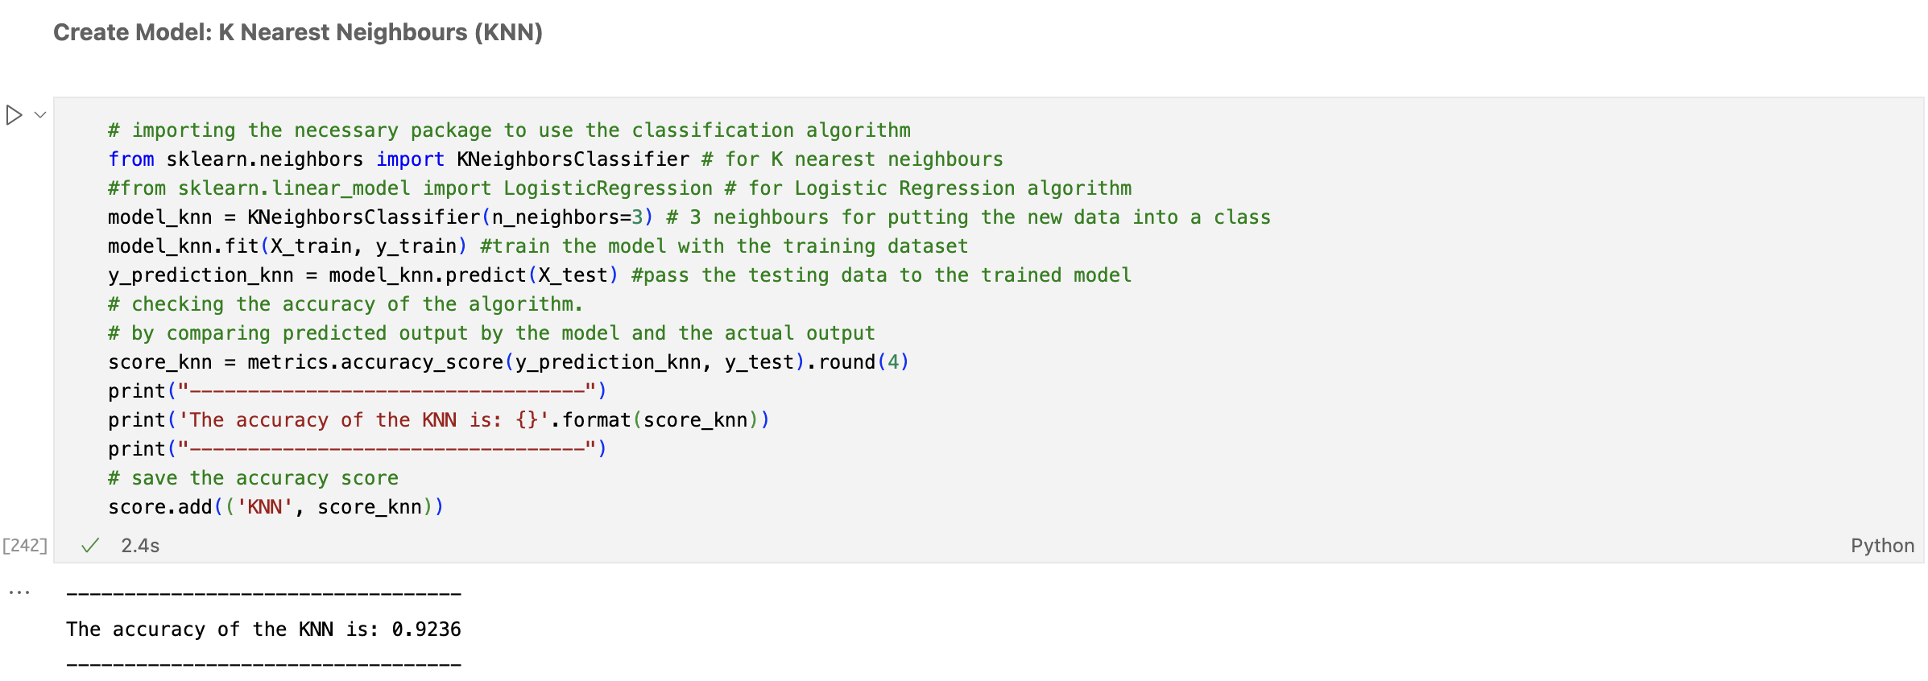

For K Nearest Neighbors (KNN) we imported the model from scikit learn and we fitted the model with both features and target for training and once the model is ready it’s tested with only the testing features and the predicted outcome is then compared with the actual outcome to find the accuracy. For K Nearest Neighbors (KNN) the accuracy is almost 92 % which can be considered excellent.

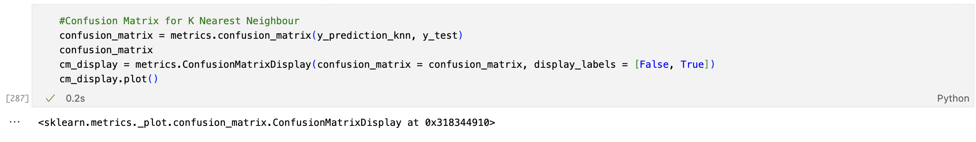

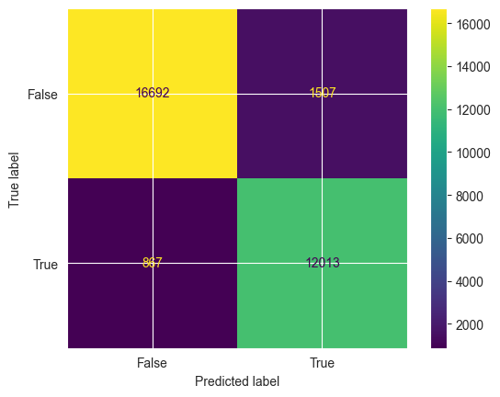

Figure: Confusion Matrix for K Nearest Neighbors (KNN)

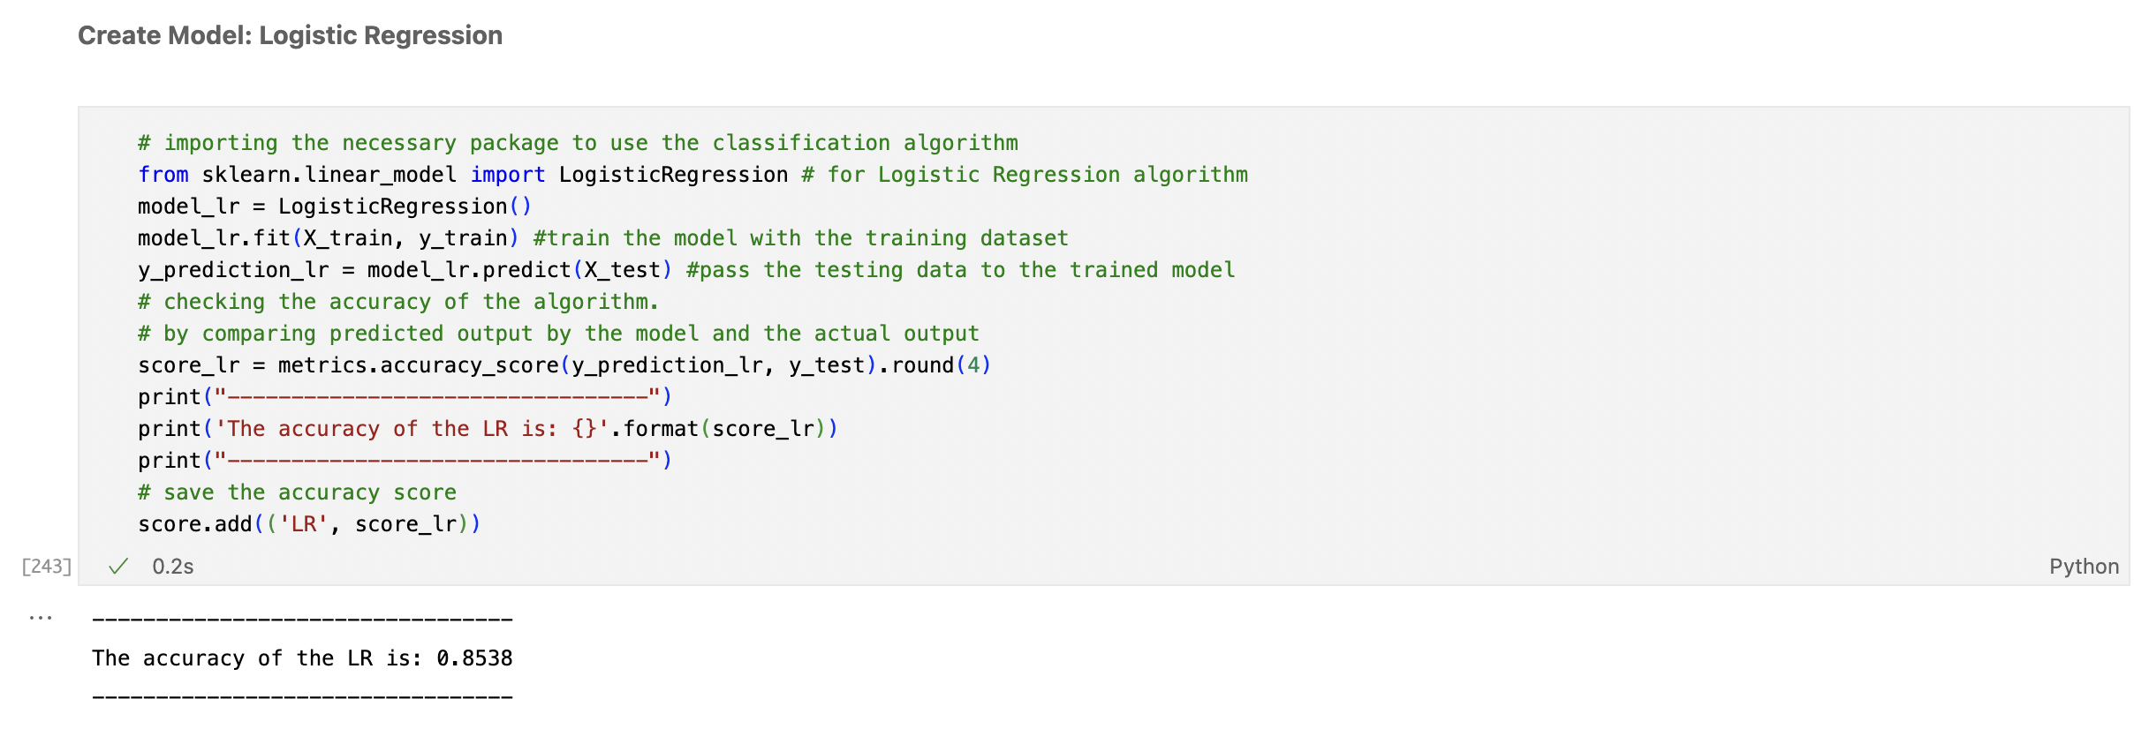

For Logistic Regression (LR) we imported the model from scikit learn and we fitted the model with both features and target for training and once the model is ready it’s tested with only the testing features and the predicted outcome is then compared with the actual outcome to find the accuracy. For Logistic Regression (LR) the accuracy is 85% which is very good.

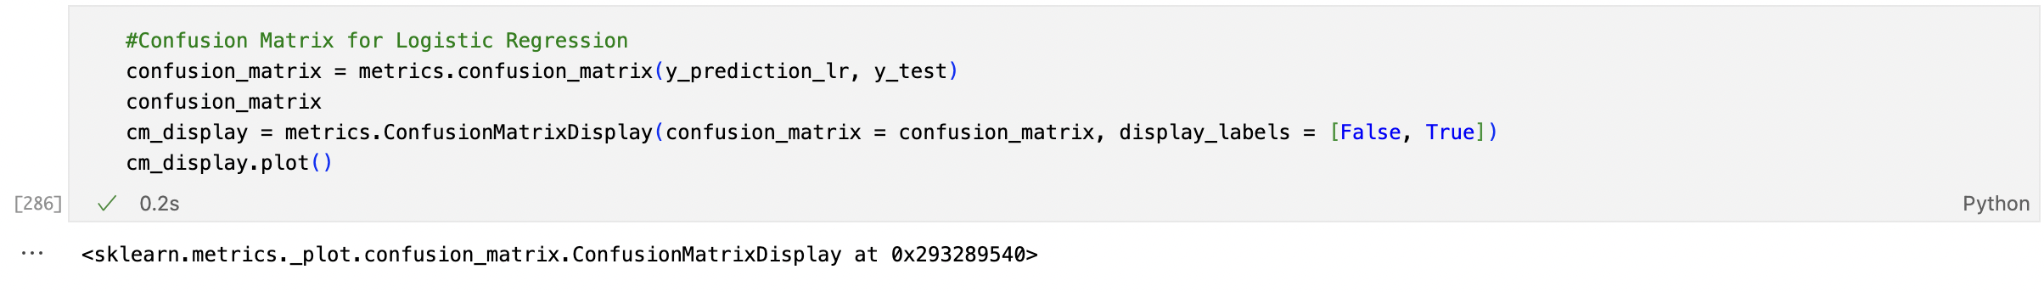

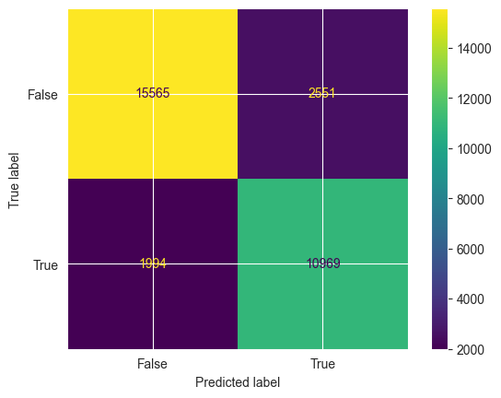

Figure: Confusion Matrix for Logistic Regression (LR)

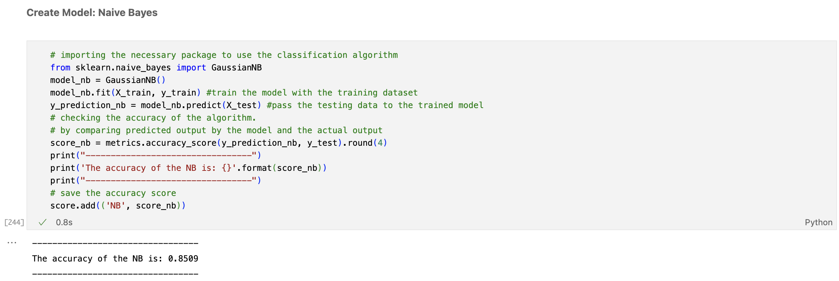

For Naïve Bayes (NB) we imported the model from scikit learn and we fitted the model with both features and target for training and once the model is ready it’s tested with only the testing features and the predicted target is then compared with the actual outcome to find the accuracy. Naïve Bayes (NB) the accuracy is 85% which can be considered as pretty good.

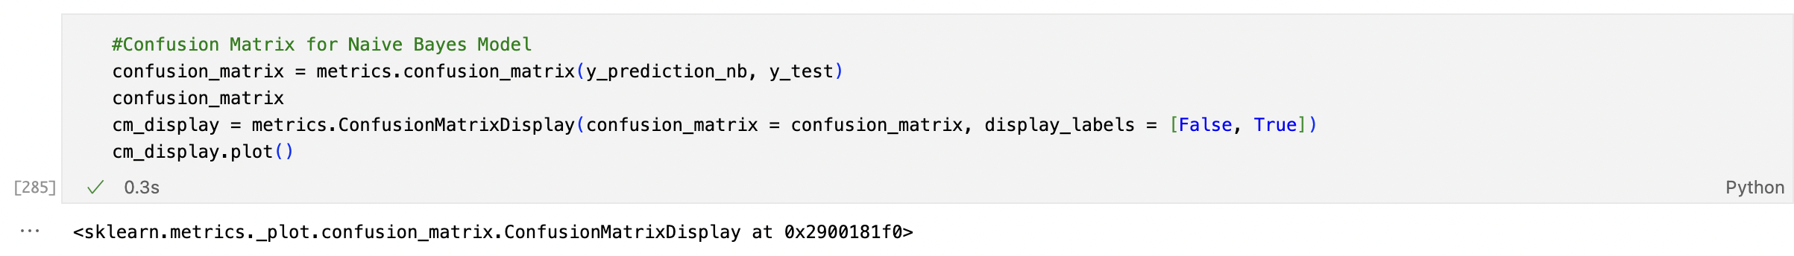

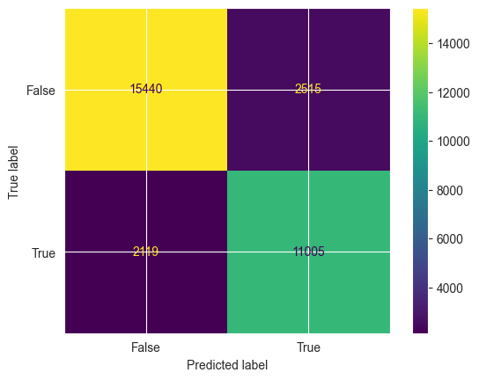

Figure: Confusion Matrix for Naïve Bayes (NB)

# **5. Discussion and Conclusion**

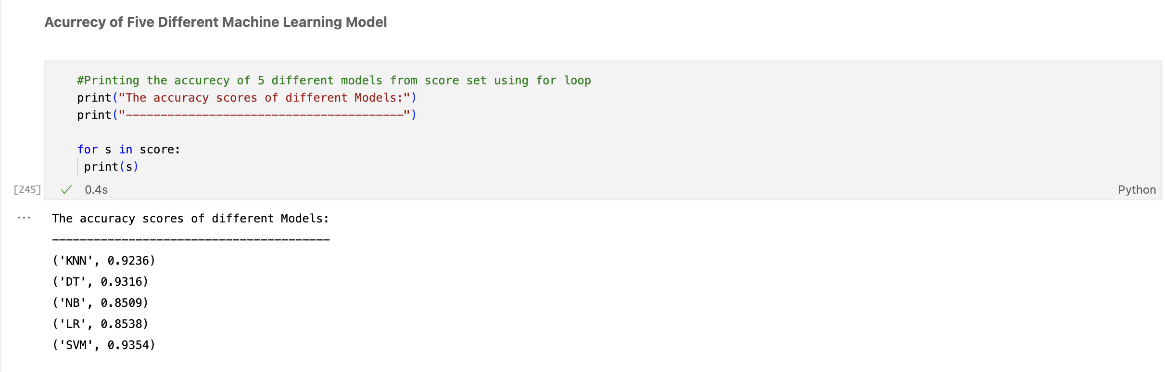

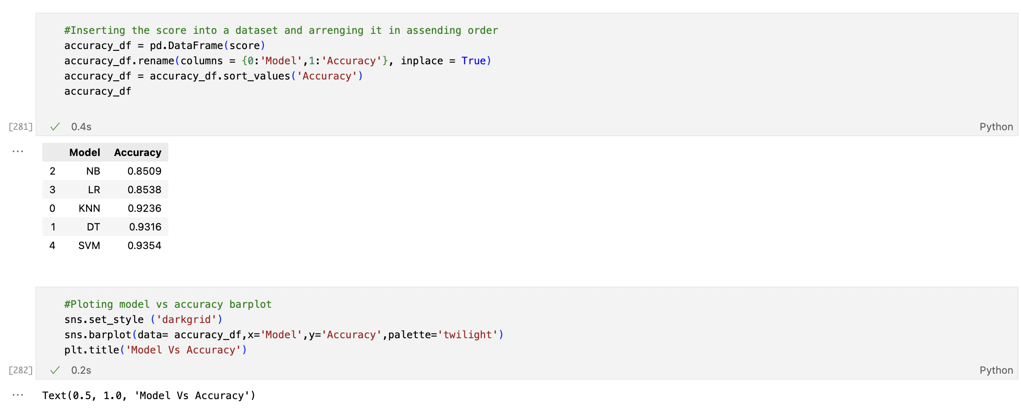

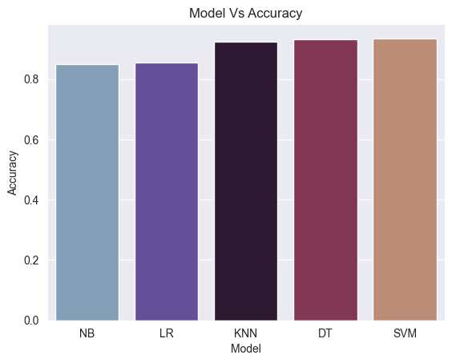

Figure: Bar Plot for Model vs Accuracy

From the given numbers and the bar plot for model vs accuracy we can say Naïve Bayes is the least accurate among the other five with the accuracy is 85% which can be considered as pretty decent. Logistic Regression’s accuracy is just fraction better than Naïve Bayes which is very good but not as accurate as next three. For K Nearest Neighbors the accuracy is almost 92 % which can be considered excellent. Decision Tree model’s accuracy is almost 93 % which slightly better than K Nearest Neighbors. Support Vector Machine with 93.5% accuracy is the best among all. The prediction accuracy of K Nearest Neighbors, Decision Tree, Support Vector Machine are more than 90% which can be considered excellent for the type of dataset we worked on.